Practice Set 2 – Sums of Squares

Some researchers at UCLA conducted a study on cyanotic heart disease in children. They measured the age at which a child spoke his or her first word ($x$, in months) and the Gesell adaptive score ($y$) on a sample of 21 children. Upon analyzing the resulting data, they obtained the following analysis of variance table:

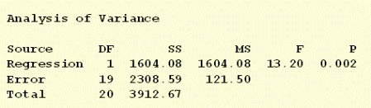

1. Which number quantifies how much the observed scores vary if you don’t take into account the age at which the child first spoke?

The number that quantifies how much the observed scores vary if you do not take into account the age at which the child first spoke is the “Total Sum of Squares” and is $\sum_{i=1}^{n}{{\left(y_{i}-\overline{y}\right)}^{2}}=3912.67$

1. Which number quantifies how far the estimated regression line is from the “no trend” line?

The number that quantifies how far the estimated regression line is from the “no trend” line is the “Regression Sum of Squares” and is $\sum_{i=1}^{n}{{\left({\hat{y}}_{i}-\overline{y}\right)}^{2}}=1604.08$

1. Which number quantifies how much the scores vary around the estimated regression line?

The number that quantifies how much the scores vary around the estimated regression line is the “Error Sum of Squares” and is $\sum_{i=1}^{n}{{\left(y_{i}-{\hat{y}}_{i}\right)}^{2}}=2308.59$